Names: Kitchen Group:_____________
Vegetable Fried Rice
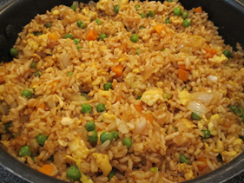
3 cups cooked white rice (1 ½ c. uncooked—follow package directions)
3 Tbsp. vegetable oil
1 cup frozen peas and carrots (thawed)
1 small onion, chopped
2 teaspoons minced garlic
2 eggs, slightly beaten
3-4 Tablespoons soy sauce
1-15 oz. can of beans (garbanzo, black or navy)

On medium high heat, heat the oil in a large wok. Add the peas/carrots mix, onion and garlic. Stir fry until tender. Lower the heat to medium low and push the mixture off to one side, then pour your eggs on the other side of skillet and stir fry until scrambled. Now add the rice and soy sauce and blend all together well. Gently stir in the beans and serve when thoroughly heated.
Prep Jobs
Measure & Cook Rice according to package directions
Measure peas & carrots and soy sauce
Chop onion
Mince garlic
Stir-Fry Veggies
Crack & Beat & Stir-Fry Eggs
Add rice & soy sauce
Gently stir in beans
Clean Up Jobs
Wash Dishes
Dry Dishes & Sink
Put Dishes Away
Wipe off Counters & Stove
Empty Garbage & Sink Drains
Sweep Floor & Towels to Basket

