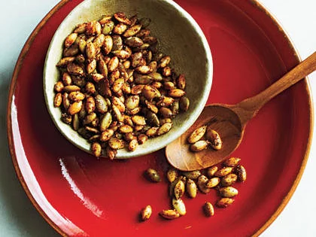
Sweet & Spicy Pepitas (Pumpkin Seeds)

1 cup Pepitas, roasted and salted
1 tbsp. Oil
1 tsp. Sugar
½ tsp. Ground Cumin
½ tsp. Chili Powder (or Chipotle)
¼ tsp. Ground Cinnamon

Place pepitas in a large skillet over medium heat. Cook for 4 minutes until lightly toasted, stirring constantly (they may pop slightly).

Measure oil and the remaining ingredients into a large mixing bowl. Add the toasted seeds, mixing thoroughly to coat. Arrange the coated pepitas on a paper towel-lined baking sheet. Let cool for 10 minutes. Enjoy!

__________________Measure pepitas and place in a large skillet. Cook over medium heat for 4 minutes, stirring constantly.
__________________Measure the oil and sugar and place in a large mixing bowl.
__________________Measure the cumin and chili powder and place in the large mixing bowl.
__________________Measure the cinnamon and place in the large mixing bowl; stir.
__________________Add the toasted pepitas to the mixing bowl; stir to coat.
__________________Line a baking sheet with two layers of paper towels.
__________________Transfer the coated pepitas to the baking sheet, spreading evenly. Cool for 10 minutes.
__________________Wash Dishes & Place lab sheet into the basket
__________________Rinse & Dry dishes & sink
__________________Put Dishes away & Place dirty towels into the basket
__________________Wipe off counters, stovetop and microwave
__________________Sweep floor & Empty garbage & Sink drains

