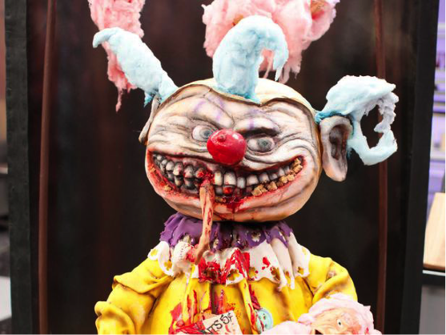
Halloween Wars
Food Science PROJECT
______ / 125 points

PRESENTATION DUE DATE: Thursday, October 25, 2018

- Teams - you will have to work together to complete your creation. Cohesive designs will do better. Communicate, be kind, work together.
- There are 4 parts to this project. Each will have a different person in charge.
Cake | This part of design must be edible and fit into design theme. Icing is required.
Rice Krispie | Must be edible, can be used for structure. Must be covered (chocolate, fondant, icing).
Pumpkin Carving | Carve pumpkin by removing seeds. Outer skin may or may not be removed, but pumpkin will have to have at least 1/5 of pumpkin carved into a recognizable design that matches theme of display.
Tasting Element | A bite-sized treat that is part of display and theme. 40 bites are required on structure. Bites must be able to keep for 4 hours on display.
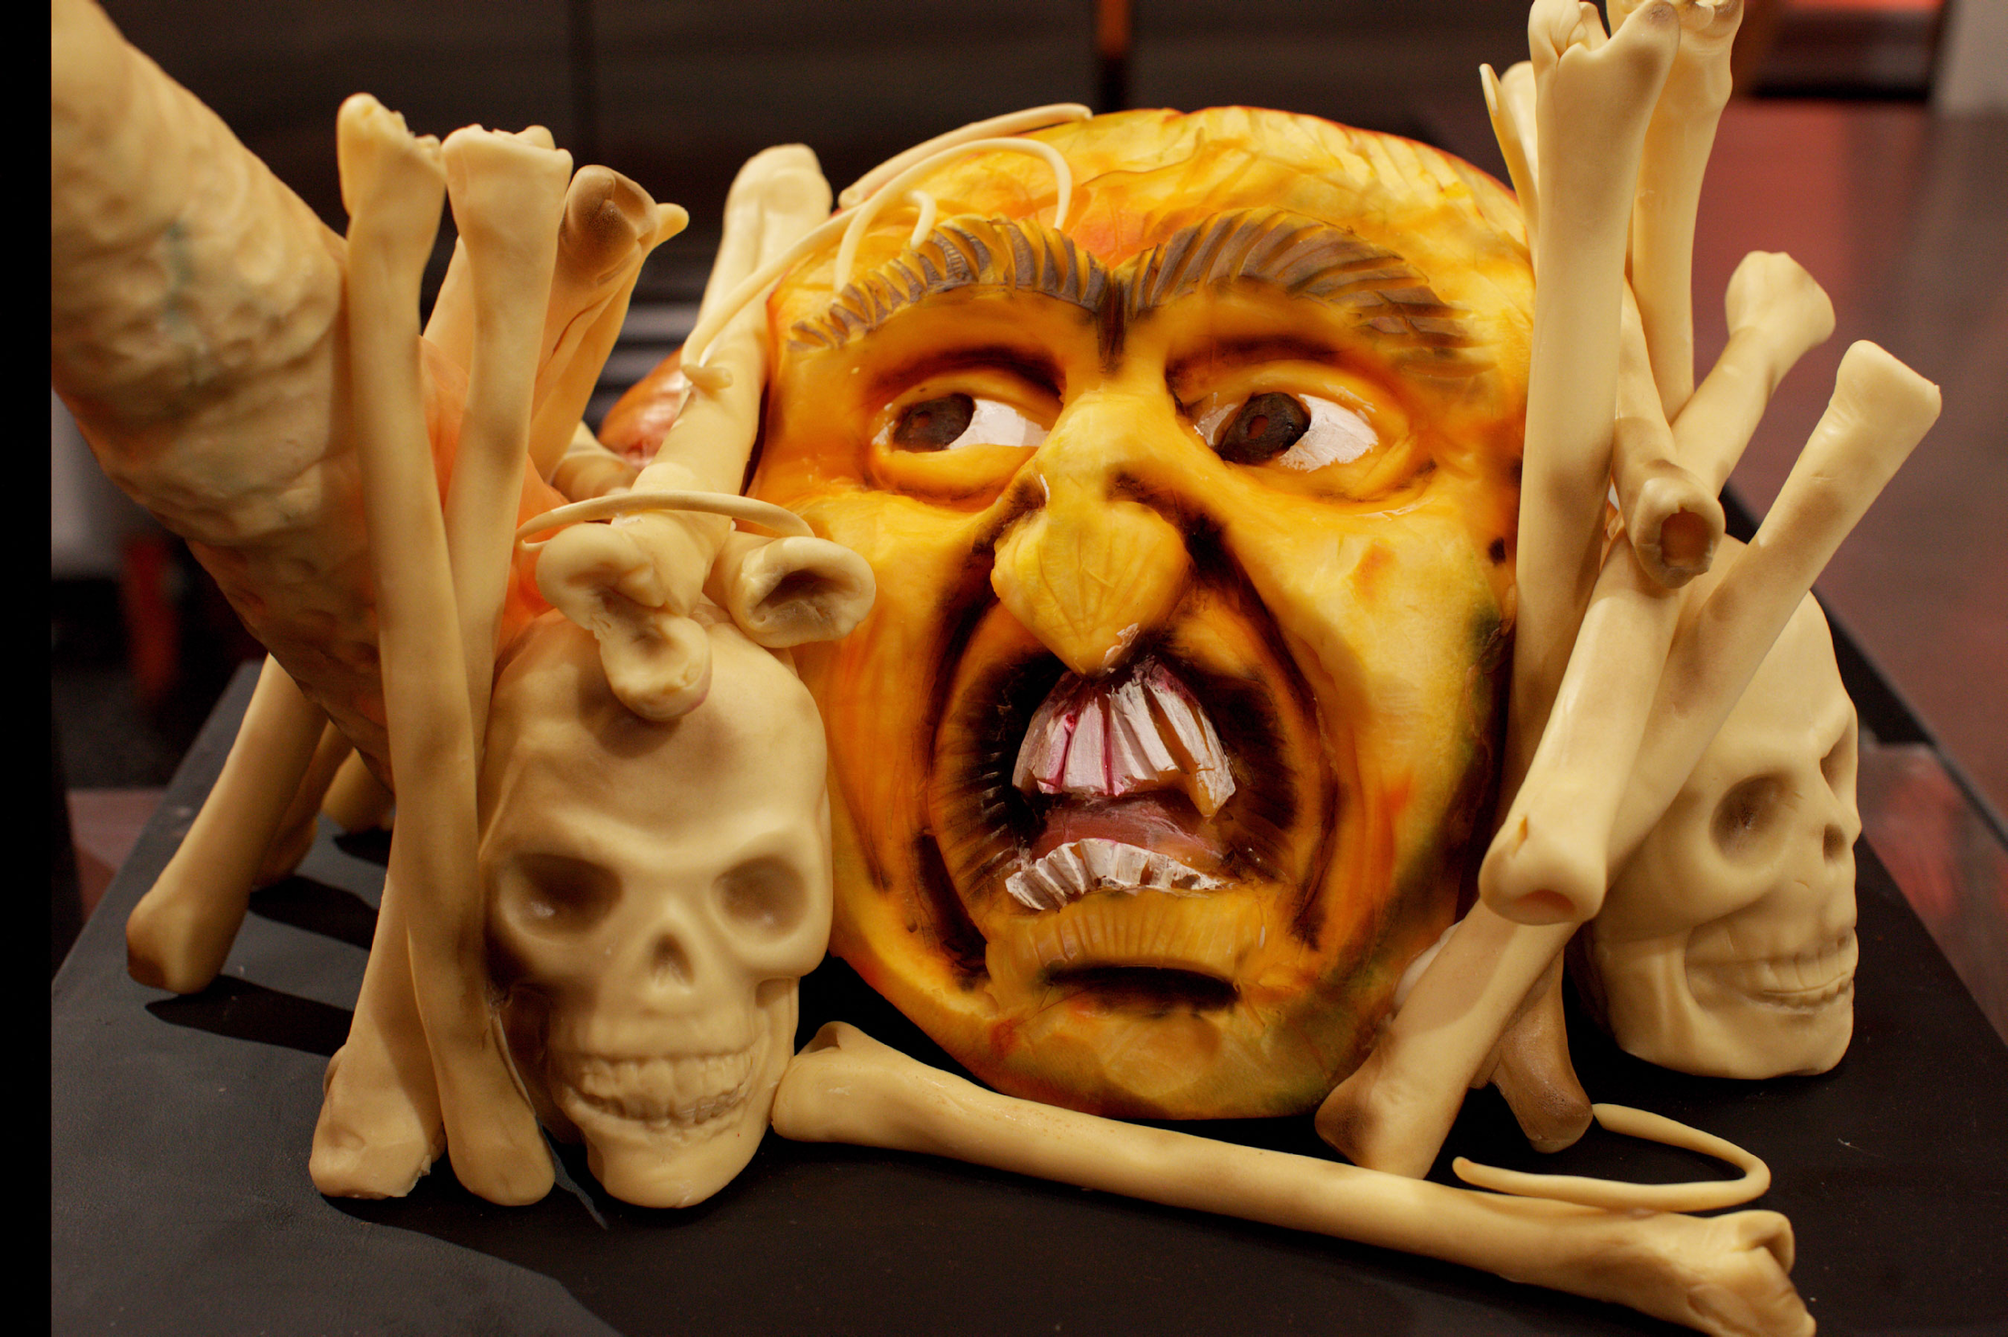
- First, you will watch Halloween Wars. Then, we will start designing and planning your project. After jobs are decided and recipes are planned, we will go grocery shopping. PURCHASE ENOUGH FOR tasting element ½ batch practice, one practice pumpkin, and then one FINAL VERSION (cake, rice krispies, tasting element for 40, pumpkin, etc.) that is a display the size of a lunch tray.

- Grocery Store Shopping – October 5
Trial Lab Dates – October 9-12
FINAL PREP for Display Dates – October 23-25
DUE by end of hour on October 25th.

- NOTE: This project will require you to make up work before school, during seminar, or after school. Be sure to complete that portion of the project if you are absent to regain your points.
- ALLOWABLE ELEMENTS: 5 props are allowed to be added to scene to help theme. They do not have to be edible. EVERYTHING ELSE MUST BE EDIBLE.

4 PROJECT PLANNING PARTS:
Person 1: Create Grocery List - must have 2 parts, practice lab and real lab. Highlight what we have, make list of things we must get at store. Give store list to Mrs. Beattie.
Person 2: Drawing of Project - must be in color, label cake, rice krispie, pumpkin carving, tasting element AND covered in fondant/chocolate, etc. Try your best to draw to scale so drawing makes sense.
Person 3: Timeline of who is making what for all TRIAL LAB DAYS
Person 4: Timeline of who is making what for all FINAL PREP lab days

Design creation and outline each person’s responsibilities  ___ / 15  DUE:  OCTOBER 4 | Grocery Store Shopping & Market Order  ___ / 15  DUE: OCTOBER 4 | Trial Labs  (Kitchen Safety and Sanitation, Teamwork, Time Management, Attention to Details, Conservation of Supplies)  ____ / 50 | Halloween Wars Evaluation  ____ / 45 points  DUE: OCTOBER 25
TOTAL |  |  | / 125 points
HALLOWEEN WARS EVALUATION
Cake | 5 – 4  Well chosen, represents theme | 3 – 2  Minor improvements could make better | 1 – 0  Distracts from theme
Cake | 5 – 4  Technique is intermediate or advanced; Proficient at skill without additional direction. | 3 – 2  Technique is somewhat intermediate and/or Properly demonstrates skill with some prompting. | 1 – 0  Technique is beginner level and/or Needs practice or coaching to meet average skill level.
Rice Krispies | 5 – 4  Well chosen, represents theme | 3 – 2  Minor improvements could make better | 1 – 0  Missing requirements: restaurant name, visual support
Rice Krispies | 5 – 4  Technique is intermediate or advanced; Proficient at skill without additional direction. | 3 – 2  Technique is somewhat intermediate and/or Properly demonstrates skill with some prompting. | 1 – 0  Technique is beginner level and/or Needs practice or coaching to meet average skill level.
Pumpkin | 5 – 4  Well chosen, represents theme | 3 – 2  Minor improvements could make better | 1 – 0  Missing requirements: restaurant name, visual support
Pumpkin | 5 – 4  Technique is intermediate or advanced; Proficient at skill without additional direction. | 3 – 2  Technique is somewhat intermediate and/or Properly demonstrates skill with some prompting. | 1 – 0  Technique is beginner level and/or Needs practice or coaching to meet average skill level.
Tasting Element | 5 – 4  Food choices are appropriate for course and are exemplary examples of theme | 3 – 2  Food choices support course and theme | 1 – 0  Little regard for course or missing theme
Tasting Element | 5 -4  Flavor components complement one another, multiple textures used | 3 - 2  Flavor could be improved or is lacking texture | 1 – 0  Flavor issues, not a cohesive dish
Tasting Element | 5 – 4  Technique is intermediate or advanced; Proficient at skill without additional direction. | 3 – 2  Technique is somewhat intermediate and/or Properly demonstrates skill with some prompting. | 1 – 0  Technique is beginner level and/or Needs practice or coaching to meet average skill level.

